
Youth Pastor – Job Advert
Holy Trinity Church, Tewkesbury
Hours: 24 hours per week
Salary: £18.5K for a 24hr/week, equivalent F/T £29K
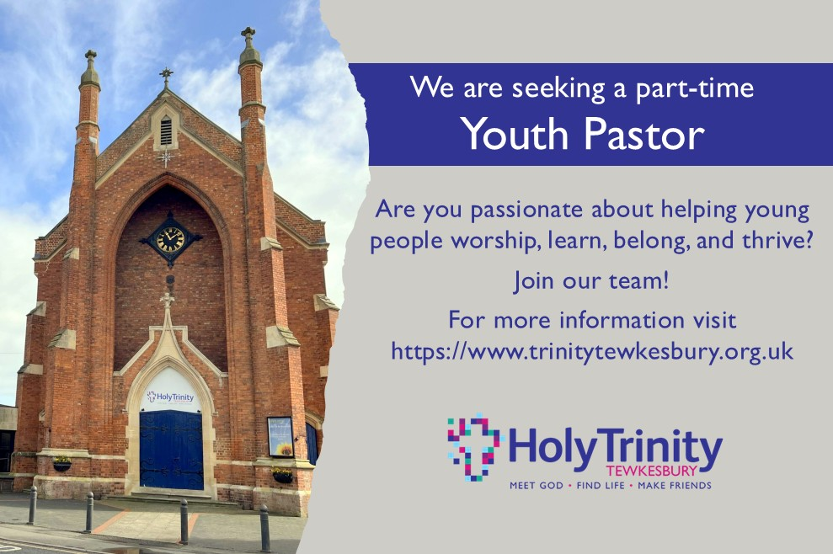
Holy Trinity is a vibrant, welcoming church family in the heart of Tewkesbury, passionate about seeing young people encounter Jesus, grow in faith, and fulfil the purposes God has for them. We are looking for a Youth Pastor who shares this heart; someone who loves being with young people, builds genuine relationships, and walks alongside them with wisdom, compassion, and joy.
We long to see our young people (ages 11–18) come to a living faith in Jesus Christ and be equipped to serve in the power of the Holy Spirit. If this vision stirs something in you, we would love to hear from you.
About the role:
We are looking for a Youth Pastor who will lead, shape, and grow our ministry with young people in school years 6–13. You will create spaces where young people can worship, learn, belong, and thrive, from Sunday gatherings and mid-week groups to one-to-one support, social events, and residential trips.
You will bring warmth, creativity, and spiritual depth, helping young people navigate life with faith and resilience. You’ll also work closely with parents, offering support and sign-posting families to appropriate help when needed, and you’ll invest in volunteers and emerging young leaders so that ministry is shared, sustainable, and flourishing.
This is a role for someone who loves Jesus, loves young people, and loves the local church.
For full details please see the Job Profile
How to apply:
To apply for this role, please download and complete our Application Form
Please email your completed form to: recruitment@trinitytewkesbury.org.uk
The closing date for applications is midnight on Sunday 12th July 2026
If shortlisted, we will contact you w/c 13th July to arrange an interview.

